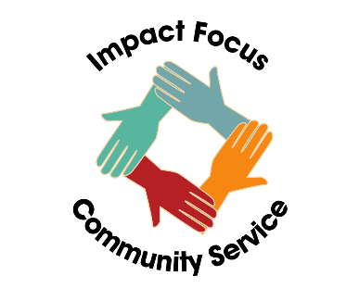

**Voracious Volunteers**

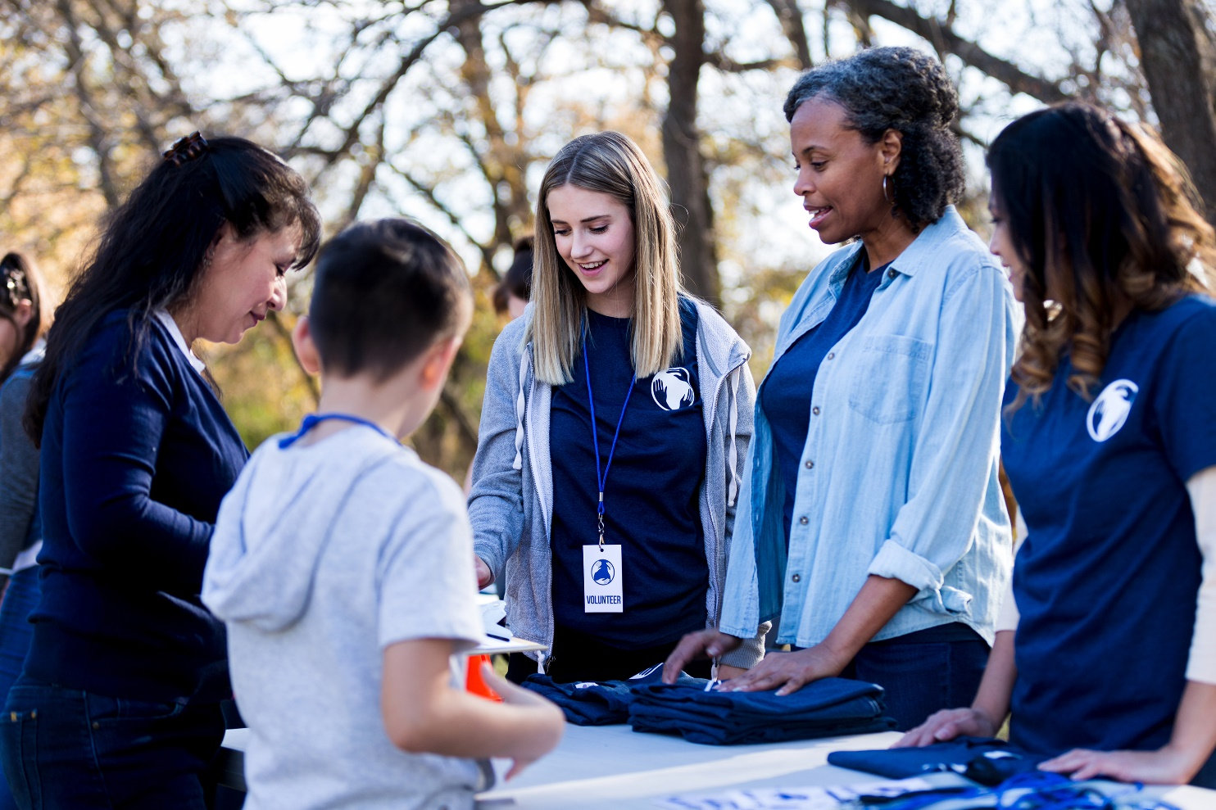

**Learning Targets**

* **Research nonprofits with volunteer opportunities**
* **Commit to using your time to make a difference**

**Standards**

* **UN SDG 17 – Partnerships for the Goals**
* **NFTE Mindsets – Opportunity Recognition; Comfort with Risk**

**Time Commitment**

* **3rd grade and up**

**Age Range**

* **30 minutes to prepare**

Young people have an innate desire to help others and it is a characteristic that shows up early in life and in common ways. Whether it is trying to help in the kitchen or at school or even sharing, helping seems to be hardwired in us at an early age. Unfortunately, it can sometimes be difficult for young people to find opportunities to be helpers, especially when it comes to volunteering. Although it can be more challenging to uncover these opportunities, it is worth it!

It is estimated that every hour of volunteering brings about $30 of value to a nonprofit organization. When you volunteer to an organization your impact ripples out to the entire population they serve. Furthermore, volunteering helps you live longer and feel happier (Cleveland Clinic, Oct. 2020)!

Determine how you can take action to make a difference in your community.

First you must learn about different nonprofit organizations in your area and figure out what speaks to your heart the most. Using your 3Ts – time, talent and treasure is the way to be a philanthropist, but this *Project Heart Beat* is all about giving of your time. Your local Chamber of Commerce or United Way will likely have suggestions for nonprofits in your area.

What problems do these organizations solve? What are the different things they do to impact those they serve? If you know a cause you’re passionate about, start your search there! Try, “animal shelters near me”, “help homeless people near me”, “food banks or community kitchens near me”.

If you’re not sure where to start, search “nonprofits near me” or “volunteer opportunities near me”. Even for young kids, there are often opportunities to help sort food and hand out groceries at a foodbank, walk dogs or brush cats at animal shelters, sort clothing and household donations for an organization that serves the homeless, connect with the city and pick up trash at local parks, and more.

Finally, if you cannot find an organization that needs your help, start very local in your neighborhood or school. Can you help a senior weed their garden or clear out a messy area? Does a neighbor need their garbage cans put away after trash day? Do you know busy people with pets that you can play with? Does your school have a lot of trash that needs to be thrown away?

Once you’ve found ways to use your time to make a difference, consider getting more kids involved!

Helpful websites could be

* <https://www.unitedway.org/find-your-united-way/>
* <https://www.humanesociety.org/volunteer>
* <https://www.feedingamerica.org/find-your-local-foodbank>
* <https://www.randomactsofkindness.org/>
* <https://www.pbs.org/parents/thrive/tips-for-volunteering-with-kids>
* <https://kidshealth.org/en/kids/volunteering.html>
* <https://health.clevelandclinic.org/why-giving-is-good-for-your-health/>

**Your Challenge**

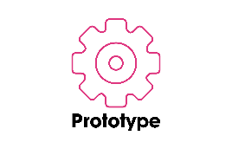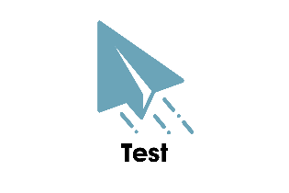

To **prototype** means to model or create an example. As it relates to Project Heart, to prototype specifically means to plan out in detail one of your impact project ideas.

To **test** means to check the quality, reliability or performance of something. As it relates to the design thinking process, to test specifically means to gain feedback on your prototype from your target population. As it relates to Project Heart, testing means implementing your plan and reflecting on your success and failures.

To **empathize** means to understand and share the feelings of another. As it relates to the design thinking process and [Project Heart](https://myprojectheart.org/), to empathize specifically means to learn about the audience or group that you wish to impact.

To effectively create change, you need to follow a plan of action. We use the Design Thinking Process to help us better understand the problem we see and walk us through steps to creating a plan to make a difference!

To **ideate** means to form an idea, thought or concept. As it relates to the design thinking process, to ideate specifically means to brainstorm ideas based on what you have learned about your target audience and the point of view or problem statement you have defined. Related to Project Heart, your ideas should also incorporate the specific time, talent and/or treasure that you wish to contribute.

**Define** means to share your problem statement with others. As it relates to Project Heart, the define stage of design thinking means you’ve thought about your personal passions and how to apply the 3Ts of your group to make a greater social impact. The define stage helps you clearly state the need or problem so others can understand.

**Getting Started**

**The Design Thinking Process**

**Activity**

**Use the spaces below to work through the design thinking process.**

Tips: To build empathy, do some research and interview experts in this area (which can include your peers!). Find out what people impacted by the war in Ukraine really need. Find out who is already helping and learn from them.

When you decide on your prototype idea, remember to access the Illumination Fund for materials funding or a matching donation to a U.S. based non-profit <https://myprojectheart.org/illumination-fund>

**Reflect**