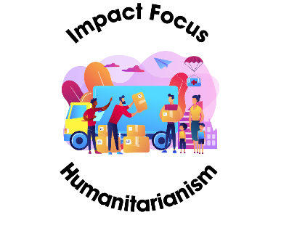

**Heart for Ukraine**



**Learning Targets**

* **Empathize with people impacted by war in Ukraine**
* **Collaborate with peers to determine how to help**

**Standards**

* **UN SDG 16 – Peace, Justice and Strong Institutions**
* **NFTE Mindsets – Critical Thinking; Flexibility & Adaptability**

**Time Commitment**

* **4th grade and up**
* **30 minutes**

**Age Range**

On February 24, 2022, the Russian military invaded Ukraine, making it the most significant war in Europe in almost 80 years. This war impacts not only the people living in Ukraine, but also neighboring countries and their families spread throughout the world. War is a very complex experience for everyone involved and disrupts all parts of life – work, school, healthcare, family time. War causes people to lose their homes because of destruction from military action or having to flee to protect their families. When people flee their homes and country for safety, they are called refugees. Refugees then seek safety and security in a new country and often never return to their old homes. This adds stress to the countries accepting the refugees. Both refugees and the Ukrainians who choose to stay in their homes are experiencing similar problems. During war schools close, which means kids stop learning. Hospitals often must evacuate and close which means injured and sick people stop getting care. Animals run away from home and are displaced from their families, causing them to be homeless and go hungry. These are just some of the needs that arise during war and when you take action to help you will make a difference.

Determine how you can take action to make a difference.

First you must decide what needs you want to impact. Does anyone in your school or neighborhood have family in Ukraine? Are there Ukrainians in America that need your help? Are there still kids in Ukraine you can help? Do you want to help the refugees who have escaped Ukraine? Can you offer help to any of the countries taking in Ukrainian refugees? Which countries are those?

Do you know what it’s like to be hungry and want to help people have food to eat? Do you know what it is like to feel afraid and want to help Ukrainian kids feel safe? Are you concerned about kids having books to read or clothes to wear? Have you lost a pet or seen homeless animals and want to help them?

How will you use your 3Ts (time, talent and treasure) to make a difference? Is there a service or product you can sell to raise money for a cause that speaks to your heart in Ukraine or the countries helping refugees? Are there items you can make or collect to send? Are there lawmakers in your town or state who you can write to and ask them for help? Can you write to companies to convince them to help in a specific way? Can you and your friends devise a campaign to encourage others to care about this cause and join in your efforts? Can you host an event to get more people involved?

Helpful websites could be

* <https://www.commonsensemedia.org/lists/best-news-sources-for-kids> (research)
* <https://www.eplocalnews.org/2022/03/09/united-they-stand-against-russias-invasion-of-ukraine/> (article)
* <https://youtu.be/8zb8xqR457Y> (video, 1:23)
* <https://www.fox61.com/article/news/local/newtown-girl-makes-care-packages-ukrainian-children-connecticut/520-af7a1fb5-8dce-4bd9-860c-94db7f8bbef3> (video and article)
* <https://www.publishersweekly.com/pw/by-topic/childrens/childrens-industry-news/article/88700-polish-literacy-foundation-leads-relief-efforts-for-ukrainian-kids.html> (article)
* <https://www.dailyrecord.co.uk/news/scottish-news/ukraine-falkirk-letter-kindness-donation-26412609> (article)
* <https://www.globalcitizen.org/en/content/ways-to-help-ukraine-conflict/> (article)
* <https://www.pbs.org/newshour/world/how-to-help-people-in-ukraine-and-refugees-fleeing-the-conflict-with-russia> (article with research links)

**Your Challenge**

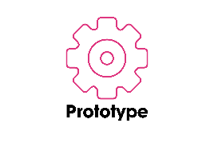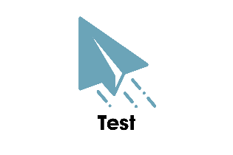

To **prototype** means to model or create an example. As it relates to Project Heart, to prototype specifically means to plan out in detail one of your impact project ideas.

To **test** means to check the quality, reliability or performance of something. As it relates to the design thinking process, to test specifically means to gain feedback on your prototype from your target population. As it relates to Project Heart, testing means implementing your plan and reflecting on your success and failures.

To **empathize** means to understand and share the feelings of another. As it relates to the design thinking process and [Project Heart](https://myprojectheart.org/), to empathize specifically means to learn about the audience or group that you wish to impact.

To effectively create change, you need to follow a plan of action. We use the Design Thinking Process to help us better understand the problem we see and walk us through steps to creating a plan to make a difference!

To **ideate** means to form an idea, thought or concept. As it relates to the design thinking process, to ideate specifically means to brainstorm ideas based on what you have learned about your target audience and the point of view or problem statement you have defined. Related to Project Heart, your ideas should also incorporate the specific time, talent and/or treasure that you wish to contribute.

**Define** means to share your problem statement with others. As it relates to Project Heart, the define stage of design thinking means you’ve thought about your personal passions and how to apply the 3Ts of your group to make a greater social impact. The define stage helps you clearly state the need or problem so others can understand.

**Getting Started**

**The Design Thinking Process**

**Activity**

**Use the spaces below to work through the design thinking process.**

Tips: To build empathy, do some research and interview experts in this area (which can include your peers!). Find out what people impacted by the war in Ukraine really need. Find out who is already helping and learn from them.

When you decide on your prototype idea, remember to access the Illumination Fund for materials funding or a matching donation to a U.S. based non-profit <https://myprojectheart.org/illumination-fund>

**Reflect**