# L1V1 – Lesson 1 Vocabulary Words

# ../.Trash/Term.png

*DICTIONARY DEFINITION:* ***giving*** *- To present voluntarily and without expecting compensation.*

IN MY WORDS:

../.Trash/Term.png

*DICTIONARY DEFINITION:* ***need*** *- To require; to be necessary.*

IN MY WORDS:

*../.Trash/Term.pngDICTIONARY DEFINITION:* ***service*** *- The act of helpful activity.*

IN MY WORDS:

*../.Trash/Term.png*

*DICTIONARY DEFINITION:* ***philanthropy*** *- the process of giving back. The act of donating money, goods, services, time or effort to support a beneficial cause and create a lasting impact. Philanthropy has a defined objective with no financial or material reward to the donor.*

IN MY WORDS:

# L1W1 - Exit Ticket

Which T of Philanthropy will I use? Why?



**TIME**

*___________________________________________________________________*

*___________________________________________________________________*

****TALENT**

*___________________________________________________________________*

*___________________________________________________________________*

**TREASURE**

*___________________________________________________________________*

*___________________________________________________________________*

----- ----- ----- ----- ----- ----- ----- ----- ----- (cut) ----- ----- ----- ----- ----- ----- ----- ---

# L1W1 - Exit Ticket

Which T of Philanthropy will I use? Why?



**TIME**

*___________________________________________________________________*

*___________________________________________________________________*

****TALENT**

*___________________________________________________________________*

*___________________________________________________________________*

**TREASURE**

*___________________________________________________________________*

*___________________________________________________________________*

# L1R1 – Teacher-to-Parent Intro Letter

(DATE) __________________

Dear Parents/Guardians,

During this upcoming semester, your ______ grade student will be participating in the Project Heart program in our class.

The Project Heart program is an innovative educational tool that provides students with the opportunity to learn about philanthropy.

The purpose of Project Heart is to encourage a habit of giving, create global awareness in children, and allow them to contribute their time, talent, and treasure toward causes and issues that they are passionate about. This program hopes to have a positive effect on students’ lives and the community they live in.

At the conclusion of this program, students will complete a special philanthropy project where they will be putting the concepts they have learned into action. This project may take the form of a fundraising and/or volunteer activity that will benefit a local nonprofit that aligns with the ‘philanthropic mission’ that the students will define. Parent volunteers may be needed at that time to help with some of the project logistics and execution.

Project Heart was created by the OtterCares Foundation, which is the charitable partner of OtterBox. We are fortunate to have this program available at no cost to our school and I am eager to have our students participate in this unique and important learning opportunity.

If you have any questions, please feel free to contact me at:

phone number ___________________ or email me at ___________________________________.

Sincerely,

_________________________________

*Interaction Activity:*

*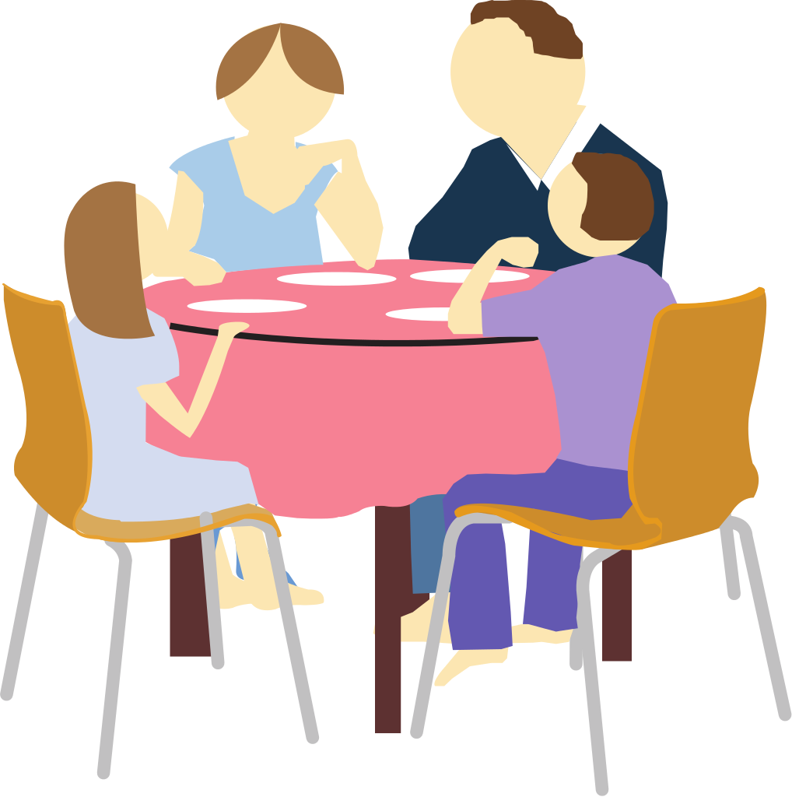Student: Ask your parent what “philanthropy” means to them. Write their answer here:*

*______________________________________________________________________________________________________________________________________________________*

*Parent: Ask your child what “philanthropy” means to them. Write their answer here: ______________________________________________________________________________________________________________________________________________________*